To the left: W room. To the right: E room. In the centre: technical corridor: 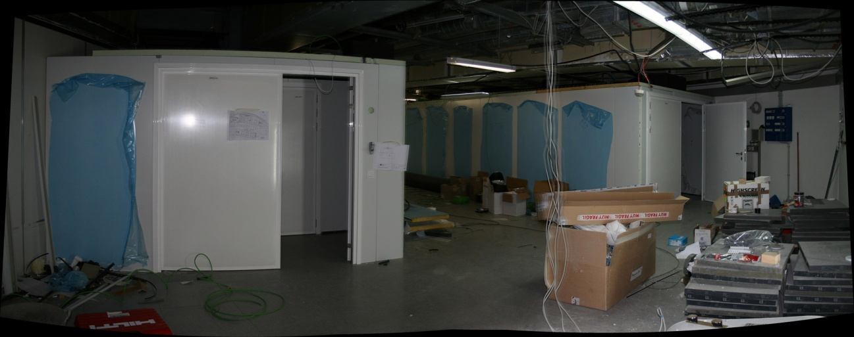
Interior of the E room, seen from the North southward:
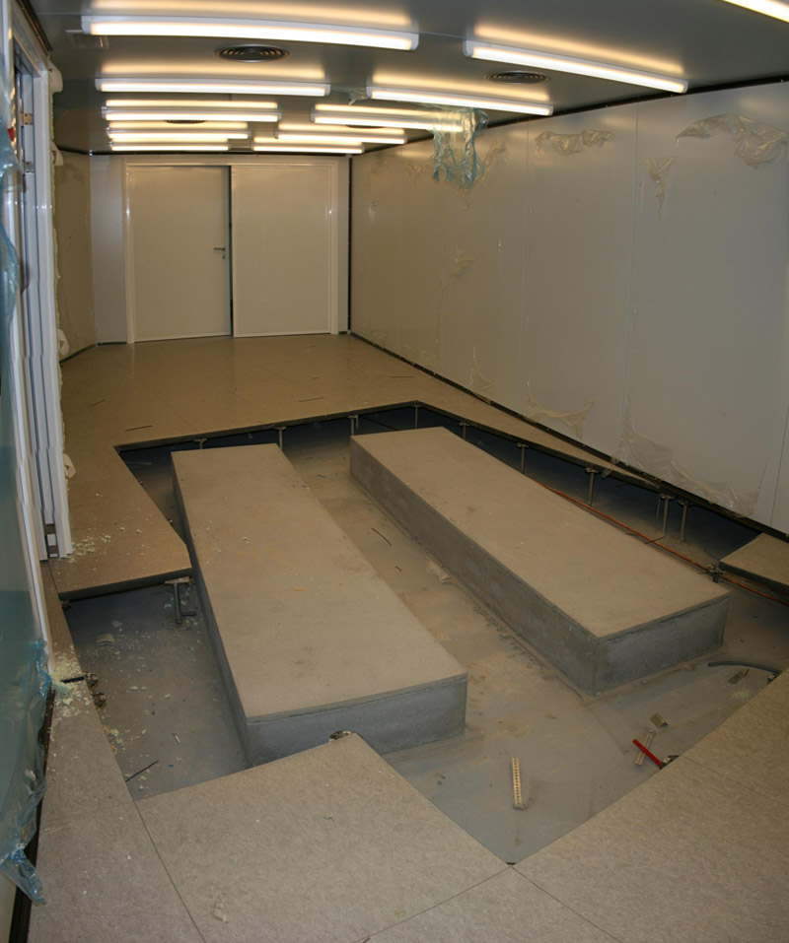
Interior of the E room, seen from the South northward:
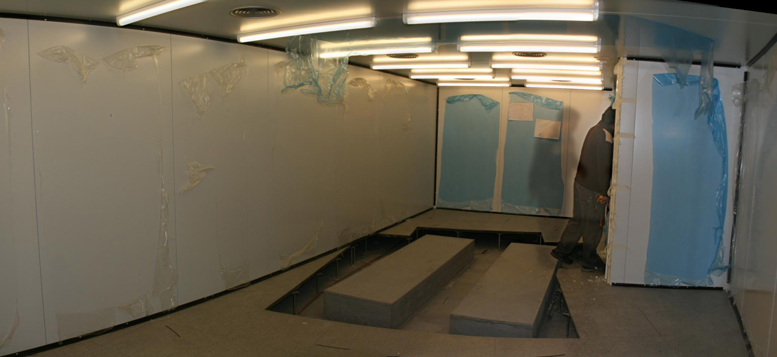
Interior of the W room, seen from the South, northward:
